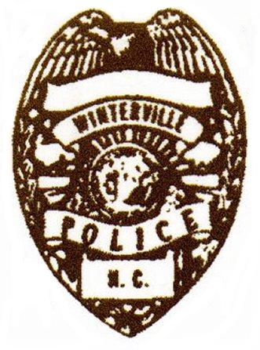
Winterville Police Department
PO Box 1459
2593 North Railroad Street
Winterville, NC 28590
Phone: (252) 756-1105 Fax: (252) 756-3458

If you have applied for a Peddler’s Permit and it was denied, you have the right to file an appeal. Along with this form, you will need to fill out a Request to Appear before the Town of Winterville Board of Alderman. Once on the agenda, we will notify you so that you may attend the next Board of Alderman Meeting and make your appeal in person.

Thank you,

Chief Billy Wilkes
Chief Billy Wilkes

Today’s Date:_______________________________

Applicant Name:_______________________________________________________________

Applicant’s Phone Number:______________________________________________________

Company/Organization Name:____________________________________________________

In a short summary, please state the reason for your appeal, including any information that you feel will make a difference in your application status.

_____________________________________________________________________________

_____________________________________________________________________________

_____________________________________________________________________________

_____________________________________________________________________________

_____________________________________________________________________________

_____________________________________________________________________________

Appeal received by:___________________________ Date received:___________________

Notified applicant of meeting date:__________________________________________________

